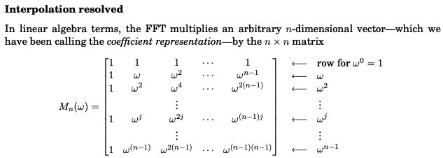

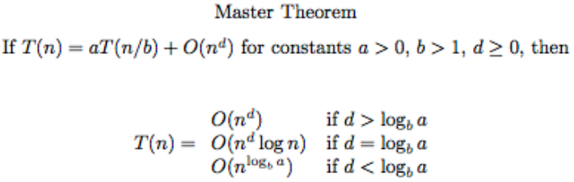

Macintosh HD:Users:amir:Desktop:Screen Shot 2019-02-14 at 3.56.51 PM.png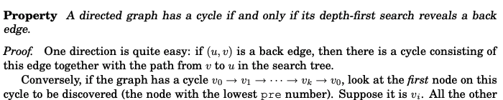Macintosh HD:Users:amir:Desktop:Screen Shot 2019-02-14 at 3.57.10 PM.pngMacintosh HD:Users:amir:Desktop:Screen Shot 2019-02-14 at 3.56.19 PM.pngMacintosh HD:Users:amir:Desktop:Screen Shot 2019-02-14 at 3.55.50 PM.pngMacintosh HD:Users:amir:Desktop:Screen Shot 2019-02-14 at 3.59.36 PM.pngMacintosh HD:Users:amir:Desktop:Screen Shot 2019-02-14 at 3.59.46 PM.pngMacintosh HD:Users:amir:Desktop:Screen Shot 2019-02-14 at 3.59.58 PM.png